Photo Credits
Video Stills by Laine Rettmer

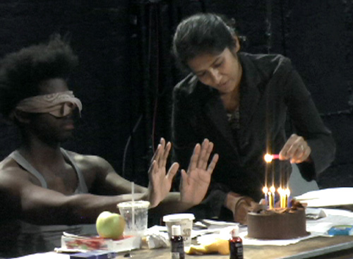
Pictured: Mikéah Ernest Jennings and Tanya Selvaratnam

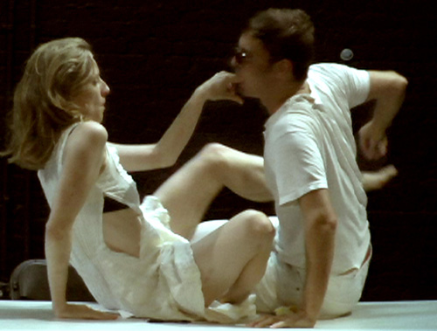
Pictured: Natalie Thomas and Greg Zuccolo

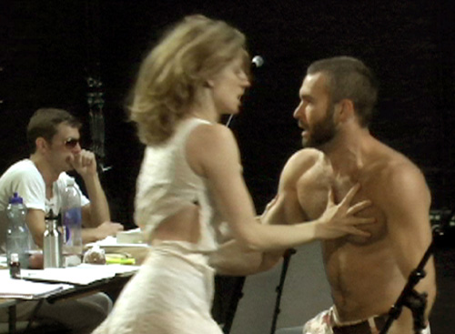
Pictured: Greg Zuccolo, Natalie Thomas, Jon Morris

jayscheib@jayscheib.com

