“In this is the End of Sleeping” after the Platonov fragment by Chekhov.
Adapted and Directed by Jay Scheib

The following are video stills from taken from the production.

Contact 917-612-2137
Or jayscheib@jayscheib.com

----------------



1. Pictured (foreground): Emily Knapp as Sasha. Video still by Leah Gelpe.

----------------

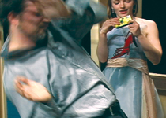

2. Pictured: Caleb Hammond as Porfiry and Emily Knapp as Sasha. Video still by Leah Gelpe.

----------------

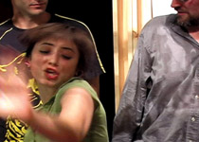

3. Pictured from left: John Dewis (background) as Nicholas, Ogla Fedorishcheva as Mary and Caleb Hammond as Porfiry. Video still by Leah Gelpe.

--------------



4. Pictured from left: Tao Wang as Osip and Emily Knapp as Sasha. Video still by Leah Gelpe.

---------------



5. Pictured: Eric Dean Scott as Platonov, Video Still by Leah Gelpe.

-------------



6. Pictured: Joan Jubett as Anna. Video still by Leah Gelpe.

