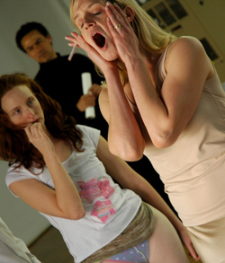

Opening November 4 at Peformance Space 122

The American Premiere of

WOMEN DREAMT HORSES

By Daniel Veronese, Translation by Jean Graham-Jones
A presentation of the BAiT (Buenos Aires in Translation) mini Festival
Creative producer Shoshana Polanco

With performances by: Caleb Hammond, Aimée Phelan-Deconinck, Jorge Alberto Rubio, Eric Dean Scott, April Sweeney , and Zishan Ugurlu
Scenic Design Peter Ksander, Light Design Justin Townsend, Costume Design Oana Botez-Ban, Dramaturgy Peter Campbell, Assistant Director Rachael Rayment

Directed by Jay Scheib

…………………………………………………………

Nothing appears as it should in a world where nothing is certain. The only thing certain is the existence of a secret violence that makes everything uncertain. Lucretius

Made with an ensemble of regular collaborators, this family catastrophe drama fills the stage with no frills. Just three couples killing each other terribly, wishing they could be in love as though the last thirty odd years of history in Argentina didn't matter. As though the last five years of history in America never happened. This ain't political science it's a comedy. And make no mistake: these guys just sort of wake up, and put the gloves on. And that's how it happens.

…………………………………………………………

Tickets: $20, $15 (students/seniors), $10 (Members)
Festival Packages Available: See all 4 for $60, any 3 for $45, any 2 for $30!
Available online at http://www.ps122.org or by calling 212-352-3101 or at Box Office. Performance Space 122 is located at 150 1st Avenue at East 9th Street.

Performance Schedule for Women Dreamt Horses:
Sat Nov 4 8:30 pm
Weds Nov 8 8:30pm
Thurs Nov 9 8:30pm
Sat Nov 11 8:30pm
Sun Nov 12 4:30pm
Weds Nov 15 8:30pm
Thurs Nov 16 8:30pm
Sat Nov 18 8:30pm
Sun Nov 19 4:30pm

Visit http://www.jayscheib.com/horses for more information.

With the support of Massachusetts Institute of Technology
and ITO-NY Actors Without Borders.

