TECHNICAL RIDER / IN PROCESS

Version 7 22 August 2012

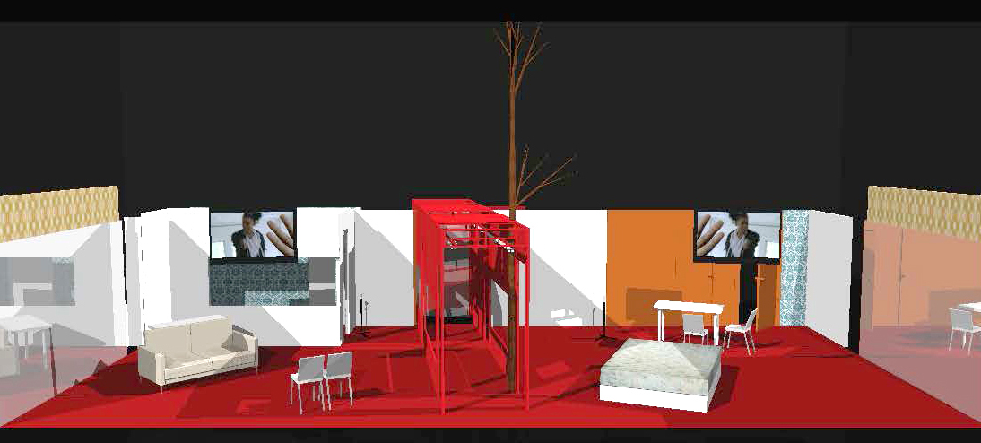

WORLD OF WIRES is a live theatrical performance adapted and directed by Jay Scheib after the film by Rainer Werner Fassbinder. Screenplay based on the novel “Simulacron-3” by Daniel F. Galouye. Running time is approximately 90 minutes.
.
Still in process

PERSONNEL

6 ACTORS
1 STAGE MANAGER / COMPANY MANAGER
1 SCENIC SUPERVISOR / PRODUCTION MANAGER
1 SOUND SUPERVISOR
1 VIDEO / LIGHTING SUPERVISOR
1 ASST. DIRECTOR
1 DIRECTOR
TOTAL: 12

SPACE AND VENUE

MINIMUM SPACE REQUIRED: STAGE DEPTH: 28 feet (8.5m)
STAGE WIDTH: 45 feet (14m)
STAGE HEIGHT: 18 feet (5.5m) height.

These dimensions represent minimum usable performance area. The total action of the performance is contained within these limits and does not include any offstage space necessary.

WORLD OF WIRES is intended for a technically contemporary theater with an end-stage configuration or a proscenium with seating directly opposite. Surround seating or a stage with more than a minimum thrust may not be appropriate for this production.

The stage design for WORLD OF WIRES consists of two rooms divided by a hallway and a bathroom defined by 8’ – 10’ (2.4m x 3m) walls at the outside perimeter. For the first 20 minutes of the production a 16’6”x 9’ (5m x 2m75) wall of cardboard boxes and a 22’ wide by 22’ (6m70) tall screen stands at the downstage edge and acts as both a visual obstruction and a projection surface. In the last 15 minutes of the production the screen returns to cover everything. A camera-person upstage of the boxes broadcasts the action via live-feed directly onto the wall of boxes and screen. This wall will be knocked down in two stages to reveal the upstage rooms. During the course of the performance, a tree will fall, and one of the doors will be kicked in.

The scenic elements are designed for a stage footprint of 45’ (14m) wide and 28’ (8.5m) of depth with an additional 8’ (2m40) of space from the downstage edge of the stage design to the first row of audience. The grid height should be no less than 18’ (5.5m). These dimensions refer to usable / visible performance space. These are the minimum dimensions of the performance space in which the production can be presented. The WORLD OF WIRES stage design may be scalable to other spaces indoors or outdoors, in traditional or non-traditional venues.

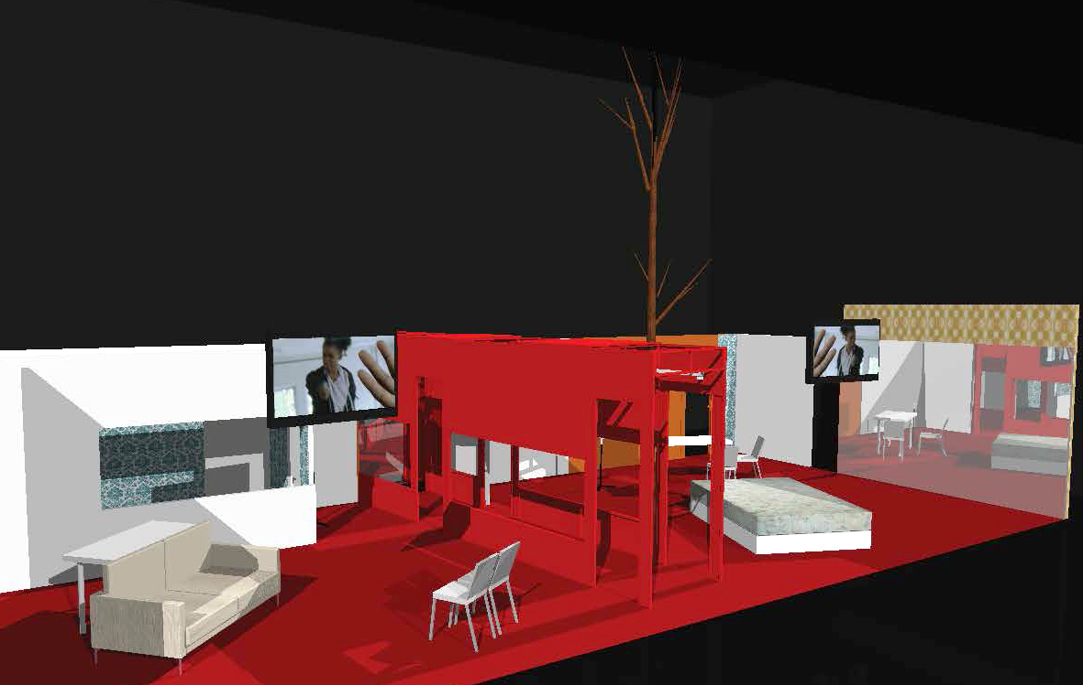

The production was developed for a stage with a fixed grid but is presentable in a proscenium setting with the addition of a support structure (not supplied by the company) for one floor to ceiling pipe that is used to help stabilize the central hallway, support a “tree” like scenic element, and to provide a “fire escape” that one of the performers climbs. The minimum dimension for the proscenium opening is 36 feet (11.5m) wide and 18 - 20 feet (6m) high. The minimum stage depth (upstage of the proscenium) is 28 feet (10.7m). In a fixed grid venue the minimum height to an over-stage grid is 20 feet (6m) and it must be possible to secure rigid pipes from floor to grid.

The scenic elements are designed to be supported by 1 floor to ceiling pipe, stage jacks and supports connected to permanent booms or additional off stage floor to ceiling pipes. The design currently assumes that it is not possible to attach anything to the stage floor. It will be necessary to rig remotely controlled release mechanism for the tree to collapse above the visible stage space.

The stage floor must be smooth, level, and either painted black or covered in black flooring. Masking will be determined on a per venue basis, but all walls must either be black or capable of being masked with black fabric provided by venue. At a minimum, masking will include a black border that spans the stage space trimmed at approximately 16'6 above the stage deck. Audience seating should be raked at no less than 10 degrees.

The loading dock of the theater must have direct access to the performance area. In venues where this is architecturally impossible, the Presenter will make all arrangements for the safe conveyance of the Company’s property from the truck or container to the theater and back again. Presenter is responsible for damage that may occur during load and off-load of the truck or container.

Note: While the stage design and staging is scalable and re-imaginable for larger, smaller, site-specific, or nontraditional spaces, — changes to the design, and development of the production for an ‘other’ space along with their costs must be negotiated with the Company

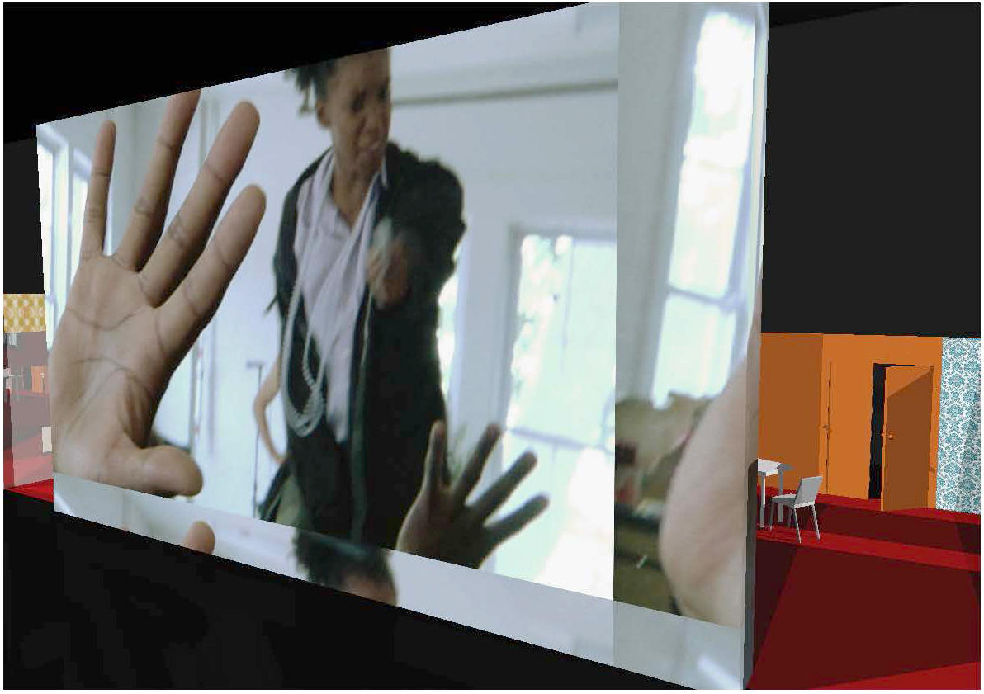

CREW AND OPERATION

The Company travels with a Scenic Designer/Production Manager, Video/Lighting Supervisor, Stage Manager, Sound Operator, Assistant Director, and Director all of whom participate in Load-In, performances, and Load-Out of the show.

In venues where English is not the common language, the Presenter will provide at least one production assistant to act as translator. This individual must be dedicated to the production team throughout Load-In, rehearsals, and performances, and should have technical theater experience.

For Load-Out, the Company requires a minimum of 8 stagehands for the disassembly of the set and the loading of the truck or container. Presenter will give priority to the disassembly, packing and loading of the Company’s materials prior to the restoration of the venue or load-in of the venue’s subsequent engagement.

These are all minimum personnel requirements for normal Load-In conditions. If there are special circumstances with regard to scheduling, crew experience, language barrier, or venue peculiarities, more than these numbers of technicians may be necessary to maintain the production schedule. The Presenter will communicate any such circumstances to the Company, and adjust crew numbers according to need. Under normal circumstances, more than these numbers of technicians would speed the production process and would be greatly appreciated.

PLEASE NOTE: The Company provides its own sound and video operators. The Company requires that these personnel be allowed to operate all equipment in their departments for technical rehearsals and performances of WORLD OF WIRES. Similarly, the Assistant Director and/or other crew members must be allowed to serve as a stagehand during performances. If Company members are not allowed to assist in scene changes, or are limited in their capabilities during Load-In and Load-Out, additional stagehands and technicians will be required.

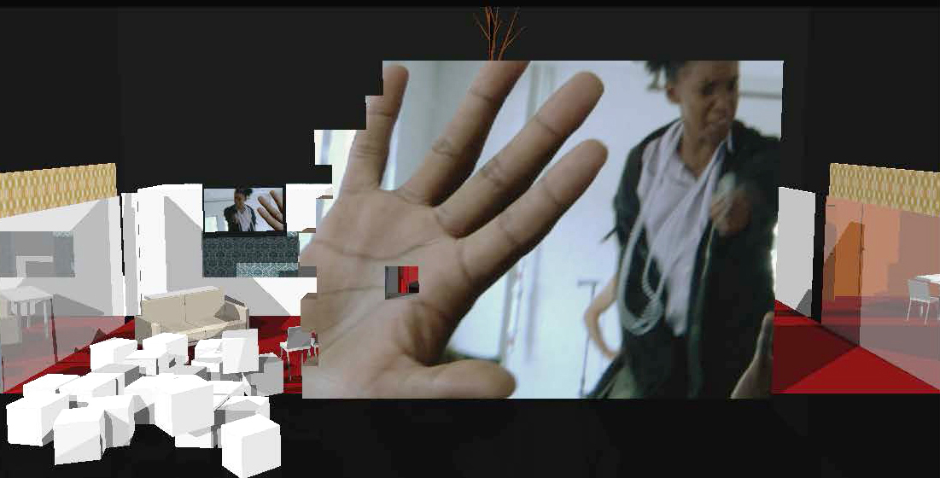

WORK SCHEDULE

WORLD OF WIRES requires 2 days from the start of Load-In to the first performance depending on size and expertise of crew. Performing on Night 3. Prior to the beginning of Load-In, all lighting instruments must be hung, circuited, and colored. The priority for Day 1 of Load-In is the construction of the set, with sound set-up happening in the morning, video set-up starting in the afternoon. On the morning of Day 2 focus and cueing for lights/sound/video, followed by technical rehearsals with all performers in afternoon and a dress rehearsal in the evening. Day 3 is a full day of notes, a technical rehearsal or run through with all performers in the afternoon and Performance 1 in the evening. The Presenter will provide exclusive and complete use of the facility and its equipment from the beginning of Load-In through the completion of Load-Out. On each performance day following the first performance, the Company requires the use of the stage in the morning for technical notes and the afternoon for performance notes. These periods will include the use of show equipment.

A detailed schedule for Load-In, technical rehearsals, performances, and Load-Out with specific personnel requirements will be prepared on a per-venue basis.

(SAMPLE) TECH AND REHEARSAL SCHEDULE

Schedule Preferred calls are 9.00-13.00; 14.00-18.00; 19.00-23.00. With staggered lunch and dinner breaks across departments if possible. Please notify us of local venue practices.

LOAD-IN / SET-UP CREW (PROJECTED)
- (4) electricians (lighting technicians)
- (1) video technician (Can be an electrician with knowledge of projector separate from lighting crew.)
- (6) carpenters / stage hands
- (2) audio technicians recommended depending on venue specifics.
- (1) Wardrobe / Costume Assistants
- (1) Rigger / Fly rail operator if necessary
- (1) Production Assistant/Translator (Where applicable)

REHEARSAL / PERFORMANCE CREW (PROJECTED)
- (1) Light Board Operator
- (1) Video Technician (for rehearsal only)
- (1) Audio Engineer/Microphone Mix operator
- (1) Titles operator (Where applicable)
- (1) Stagehand / Running Crew Person
- (1) Wardrobe Person
- (1) Production Assistant/Translator (Where applicable)

LOAD-OUT / STRIKE CREW (PROJECTED)
- (8) Stagehands / Carpenters
- (1) Video Technicians
- (1) Audio Technician
- (2) Wardrobe / Costume Assistants

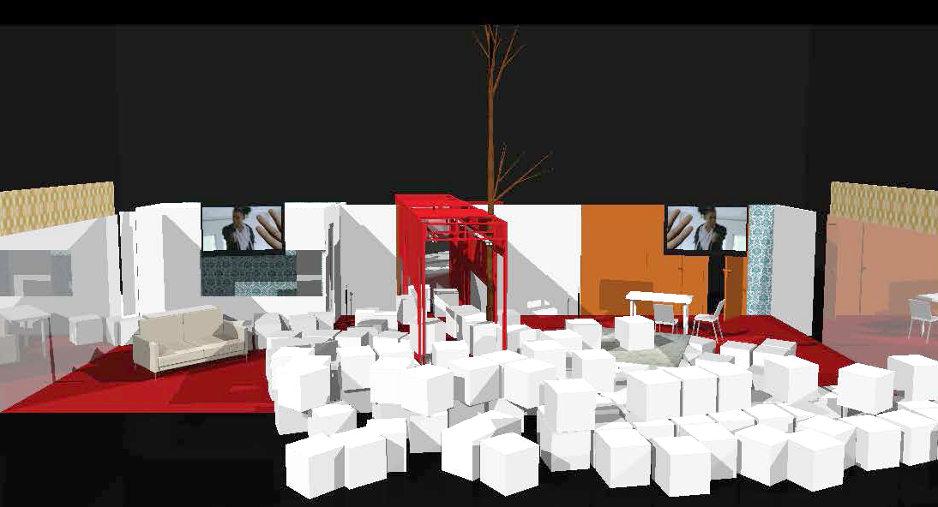

SAMPLE SCHEDULE
Preferred calls are 9.00-13.00, 14.00-18.00, 19.00-23.00. Please notify us of local venue practices. Crew: 4 electricians, 1 video technician, 6 carpenters, 2 audio techs recommended depending on venue specifics.

The following Sample schedule is based on performing in the evening of Day 3. It is possible to perform on the evening of Day 2 but will likely require slight increase in staff during load-in. Both schedules presuppose lighting instruments pre-hung to specifications provided.

Day 1: 09.00 – 13.00 Load in and Build (Carpenters and Electricians)
14.00 – 23.00 Video and Audio Set Up and Focus / Light Focus (Add video and Audio)
Rehearsal 14.00 – 19.00 Actors rehearse in separate rehearsal studio

Day 2: 09.00 – 12.00 Finish Focus and Scenic Notes
12.00 – 14.00 Video and Sound Staggered Break for Quiet Time / Audio
14.00 – 18.00 Light and Video Focus Finish / Rehearsal with Actors on Stage
19.00 – 23.00 Dress Rehearsal followed by Notes

Day 3: 09.00 – 13.00 Build / Light and video Focus Notes
14.00 – 18.00 Second Dress Rehearsal with/out blood and continued notes
19.00 – 23.00 PERFORMANCE #1

Day 4: 09.00 – 13.00 Technical Notes/Work
14.00 – 18.00 Rehearsal/Notes (TBA)
20.00 PERFORMANCE #2

FINAL DAY 14.00 – 18.00 Rehearsal/Notes (TBA)
20.00 LAST PERFORMANCE
21.30 – 25.00 PRODUCTION STRIKE and LOAD-OUT

(All company gear (video/costumes/screens etc. struck) Venue strike beyond striking and loading out Production equipment is at discretion of Presenter.

SCENIC ELEMENTS

WORLD OF WIRES is composed of the following scenic elements (PLEASE NOTE THAT CHANGES TO THE SCENIC DESIGN ARE CURRENTLY UNDER WAY. MATERIALS AND SETUP TIME WILL BE EQUAL TO OR LESS THAN WHAT IS HERE DESCRIBED):

Company will provide:

- Physical scenery

- 17 – 4’x8’ flats including one with a door
- 2 – hollow core doors
- 4 – 2’x8’ flats
- 2 – 4’x2’ flats
- 4 – custom flats approximately 4’x8’
- 3 – 4’x8’ plexiglass mirrors
- Steel hallway consisting of 14 steel flats and 6 steel supports
- One toilet
- One sink
- One small sofa
- One single mattress
- Carpet to cover 20’x 35’ of the stage floor
- 60 cardboard boxes to erect as a screen at the downstage edge of the stage design’s foot print. (The wall is approximately 15’x26’2”)
- projection screen rigged at front of stage at 18’ x 22’ (height variable)

- Additional hand props, dressing and furniture

- Coffee maker
- Coffee cups
- Fresh Flowers
- Two pairs of Scissors
- Cheap vase
- 2 very fake guns (silver spray painted water-pistols)
- 1 blank pistol – multiple rounds are fired during the course of the performance
- Papers and folders
- 4 folding Chairs
- 4 plywood chairs
- 1 – 30” x 60” steel table
- 1 – 20” x 48” steel table
- 1 – 3’x 3’ folding table
- Water bottles
- Newspapers
- EMT bag and supplies
- Cigarettes and electronic cigarette
- 20 cans of Original flavored Pringles
- 20 Water bottles
- Aspirin bottle with edible faux pills
- 1 piece of fresh edible pizza in a Styrofoam container
- 6 cups of fake blood
- 1 wall phones
- 4 cell phones (2 smart phones)

Presenter will provide:

- Rigging to hang or attach the front of house projectors in such a way as to make them free of vibration and movement.
- Upstage RP plastic (if deemed necessary on a per venue basis)
- DMX controlled Fog Machine
- Additional masking may be required, and will be determined on a per venue basis.
- All prop tables, back stage chairs, and mirrors, the location and number of which to be determined.
- Quick-change booth of at least 50 square feet located upstage left.
- All running and work lights necessary for performers and operators.
- One black border that spans the width of the stage space. Height to be determined based on the venue

On a per venue basis for the purpose of decreasing shipping costs the company is open to detailed discussion of materials and scenic elements.
- Red carpeting
- Free-Standing Toilette
- Twin Mattress
- Four black folding chairs (the cheapest made—ikea, metal with plastic backs)
- One functional coffee machine (drip/filter coffee)
- An array of standard flats. Plexi-glass mirror

FREIGHT

The set of WORLD OF WIRES and Company equipment fits comfortably in a 40-foot sea container or single 53 foot trailer. Weight of the total package has yet to be determined, but total volume is under 1000 cubic feet (30 cubic meters).

For engagements in which air-freight of set pieces and equipment is necessary, the Company will attempt to minimize the number and size of items requiring transport, and may ask that the venue provide certain bulky items such as carpet and a mattress prior to the Company’s arrival.

In venues where replacement of Company set pieces is negotiated to minimize shipping costs, the Presenter will provide replacements to the exact specifications of the Company. Presenter will insure that any construction required will be completed prior to the Company’s arrival. Any inability to meet the Company’s specifications should be communicated to the Company prior to arrival. Arrangements made incorrectly may delay the Load-In and show schedule. Any expense, including the hiring of technicians to address corrections or possible cancellation of performances, will be the responsibility of the Presenter.

POWER

WORLD OF WIRES requires clean, separate power for Electrics, Sound, and Video. Priority should be given to ensuring that all video is powered using the same phase. Presenter will provide power conditioners if there are electrical issues in the venue.

In venues outside of the United States, Presenter will provide as necessary regulated step down converters to accommodate company’s equipment. Converters must be appropriate for electronics, and have zero ground bleed.

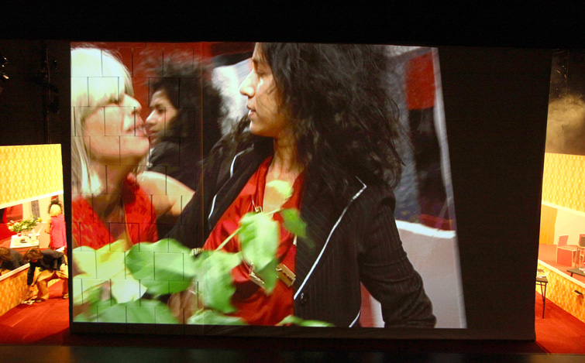
Photo from The Kitchen WORLD OF WIRES

VIDEO

The video design for WORLD OF WIRES is based around the real-time transmission of one live video-feed to two monitors on stage and a single projector. And one live feed to a single monitor located in the “bathroom.” The Company travels with the majority of equipment necessary to accomplish the design.

Presenter will provide:

Clean and separate power to projectors and to mix position. Video mix position will require full view of stage.

(1) 50" flat plasma screen monitor stage left rigged at 6’6” from the floor.
(1) 50" flat plasma screen monitor stage right rigged at 6’6” from the floor.
(1) 17” television monitor with bnc or svideo inputs (Ntsc)
(4) round-base, black microphone stands and black sand-bags
(2) composite video cable runs from camera position on stage to video mix position (one camera and one extra "emergency cable")
(2) composite video cable runs from distribution amplifier position stage left or right to video mix position (two for cameras and one extra "emergency cable")
(1) composite cable run from video mix position to 50" monitor in "living room"
(1) composite cable run from video mix position to 17" monitor in "bar"
(1) VGA or DVI cable run from video mix position to projector
(1) Composite video cable run from Mixing board to projector
(1) 10-12k Lumen HD Projector with full HD resolution and an SDI input. We prefer Panasonic PT-DZ8700U. (Please confirm projector order with Video Designer at least 2 weeks before production)

(1) Voltage Regulator / Power Conditioner or equivalent at mix position (Furman P-3600 AR Pro or equivalent - for venues outside of the U.S.)
(2) 13" monitors at mix position for monitoring of video cameras
(1) 20"- 23" computer monitor compatible with mac (dvi)
(1) Ethernet cable runs from the mix position to the projectors — to control the in-unit shutters of the projectors (eliminating the need for dowsers).

Company will provide:

(1) Mac Tower with associated software and video capture cards
(1) Mac Laptop for running video to monitors in "Living Room" and "bar"
(1) Vertical interval matrix switcher
(1) Edirol V8 Video Mixing Board
(x) all associated cables at mix position
(1) midi box and cables
(1) rs232 usb control box and cables
(2) backup 3ccd "emergency" cameras
(1) Panasonic hpx170 Camera
(1) Panasonic 3 chip camera with tripod arm
(1) Kramer Distribution amplifier.

SUPER TITLES

In venues where projected translation is desired, the Presenter will provide a system through which the text can be projected above the stage. The Presenter will provide a Black projection surface hung above the final position of the front border, where it will not block line of site to any part of the stage from any seat in the audience, or block any speaker positions. Size, material, and exact location of super title screen must be discussed with the Company prior to arrival.

Wherever possible, the super title projection system is to be operated by an individual familiar with the production and the translation, be it the translator or the Company Manager. If so, the Presenter will provide a bilingual assistant familiar with the projection system whenever that system is to be used: each rehearsal, performance, and note session. If the translator or Company Manager is unable to operate the super title projection system, the Presenter will insure the operator of the translation is given as much time as possible to rehearse with video tapes of the show, as well as rehearsals in the venue. The Presenter will insure that the operator is an experienced performer capable of adapting to changing timing and performances.

NOTE* During the first 20 minutes of the performance the subtitles will be worked into the live video feed much as subtitles in a typical film. A separate projector for handling the subtitles will be necessary.

LIGHTING

WORLD OF WIRES requires a computerized lighting console with full cue tracking and multi-part cue capability. The console must be capable of handling no fewer than 250 channels and 200 cues. It must have 2 timed fader pairs, a minimum of 24 programmable sub-masters. An ETC Eos or Ion is the production’s preferred lighting console. Presenter will specify the manufacturer and model of the console to be used and, if requested, provide appropriate operating manuals no fewer than 8 weeks prior to load-in for Company approval.

In addition, the console must have remote monitors or be moveable to a tech table located in the middle of the house for the rehearsal period prior to the first public performance.

The light plot consists of approximately 150 conventional lighting instruments. All ellipsoidals (profiles), should, wherever possible, be ETC Source 4 ellipsoidal reflector spots, or instruments of a comparably recent age as ETC fixtures (e.g. Strand SL series, Selecon). Non-axial equipment is unacceptable.

Attached here is an approximate list of what instrumentation is necessary. IT DOES NOT REPRESENT THE EXACT INSTRUMENTATION REQUIRED. Being that all venues have slightly different sizes and configurations, these numbers will shift on a case-by-case basis. They are included here to give a sense of the scale of the production:

12- Double Tube dimmable fluorescent fixtures
8 - ETC S4 50° Ellipsoidal Reflector
31 - ETC S4 36° Ellipsoidal Reflector
6 - ETC S4 26° Ellipsoidal Reflector
19- 19 ETC Source 4 19º Ellipsoidal Reflector
29 - 8” Altman 2k Fresnel
10- Broad Cyc Three Channel Cyc Lights

Presenter will provide all gel (color filters), and rental of any specific additional lighting equipment necessary to supplement the venue’s inventory, to be determined by the Company lighting supervisor on a per venue basis.

The show requires a minimum of 96 dimmers at 2.4kw.. All dimmers must operate on DMX 512 protocol. If venue is equipped with analog dimmers, the lighting console must have a second DMX universe for operation of scrollers as well as a digital to analog converter to convert DMX signal to the house dimmers. Presenter will provide DMX cable and scroller cable in sufficient length and quantity for operation of scrollers and ColorBlasts in locations shown in the light plot. This information will be different for each venue, and determination of the exact cable requirements is the responsibility of the venue's electrician or other venue staff.

Presenter will provide the necessary crew to focus all lighting instruments. WORLD OF WIRES can be focused in 6 hours if 2 focus crews (Two Electricians Per crew) are provided to work simultaneously.

Company will provide specific lighting information and light plot for each venue. The Company will also provide a list of cues to be programmed into the lighting console upon the Company’s arrival or sooner at the venue’s request.

Presenter will provide a table of sufficient size, with good line of sight to the full stage, for the Company Lighting Supervisor to sit at during the show and to call the show from, or in the case that the supervisor is operating the board, access to a front of house position, with good line of site, to operate from.

PLEASE NOTE: All lighting units must be hung and circuited with color dropped and dimmers patched prior to the commencement of load-in of Company's scenery and equipment.

SOUND

SOUND DESIGN FOR WORLD OF WIRES IS STILL IN DEVELOPMENT AND THE FOLLOWING IS AN ESTIMATE. WORLD OF WIRES requires a public address sound system with discreet Front Left, Front Right, Rear Left and Rear Right and subwoofer channels and any speakers required for delay and coverage that are normal for the venue, all with 32-band EQ. Speaker system should be capable of delivering 100dB(A) to all areas of the auditorium from 20 - 20000HZ without distortion with sub bass units (preferably driven from an auxiliary send). Particular attention should be given to side seats and extreme front seating. The whole system should be quiet and free of noise. The console must be positioned in the centre area of the venue preferably not under balcony or in booth.

The use of house delay zones will be determined on a per-venue basis. Presenter will provide speakers, subwoofers, monitor wedges, and delays the number of which will be determined on a per venue basis. Presenter will provide amplification, cabling, and interconnect, as well as all rigging hardware required to fly speakers as needed and to rig microphones. Presenter will determine all necessary cabling and interconnect based on microphone, speaker and mixing positions determined by the Company.

Presenter will provide a public address microphone located in the house for rehearsal purposes, and Clear Com communication (including headsets, belt packs, and cabling) for all rehearsals and performances in the following locations:

- 2 front of house positions at the sound desk.
- 1 front of house position at the director desk
- 1 front of house position during tech for stage management at director desk
- 1 onstage position in the upstage left
- 1 onstage position in the upstage right corner.
- Any additional locations for the light board operator, fly rail operator, and translation-subtitles operator as necessary.

The sonic environment of WORLD OF WIRES is comprised of music playback from a MAC laptop and an array of onstage microphones. The action plays out in a series of rooms and is amplified via one moving shotgun microphone mounted on a camera that is operated by a cinematographer who follows the action from room to room. Other amplification is provided by stationary microphones mounted to provide coverage in the other rooms. Sound files and cuing are currently operated from qlab but may be ported to other systems/platforms as necessary…

Company will provide:
(1) Mac Laptop with associated software to provide playback of sounds
(1) Sennheiser EW100 G3 clip-on wireless transmitter for on camera shotgun microphone
(4) Sennheiser shotgun mics and mic clips
(2) Crown Pcc 160 microphones

Presenter will provide:
(1) Sennheiser wireless receiver with a range of 626-668 mhz.
(2) Condenser microphones to be hung above the stage left room.
(3) Hand-held wireless microphones. (Sure slx24/sm58 or equivalent)
(4) Cardiod boundary microphones (crown pcc-160 or equivalent)
(3) Mic Stands (preferably four with tripod bases and boom arms and two with round bases.)
(3) Sand bags for the mic stands.

SPECIAL EFFECTS

WORLD OF WIRES makes use of a 9mm blank firing pistol. Twelve shots are fired from the pistol over the course of a single performance. We ask that in venues outside of the United States that the presenter provide blank pistol and cartridges sufficient for three rehearsals and all performances.

WARDROBE

The Presenter will supply laundry and dry cleaning services for all costumes. Laundry facilities must include washer, dryer, ironing equipment and a steamer. One or two Wardrobe person(s) should be on site at the time of Load-In to arrange for dry cleaning and laundry. Some costume elements must be cleaned, pressed, and ready for dress rehearsal the following day. One Wardrobe person must be available during each performance to launder selected costume pieces before the next performance, and will be asked to clean and pack costumes and costume-related props during load-out. The Company requires a quick-change booth upstage left. The booth must at least 50 square feet in dimension, large enough for two actors in addition to chairs and mirrors, and have a small clothes rack or wall hooks. The Company also requires a second clothes rack of no less than 6 feet (1.8m) of length to be used backstage for the storage of additional costumes.

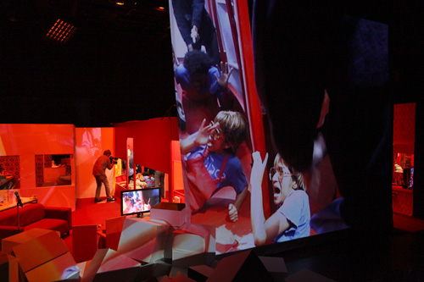

DRESSING AND REHEARSAL ROOMS

The company of WORLD OF WIRES consists of 4 female and 2 male performers, and requires separate dressing rooms for men and women. The Technical crew consists of 5 individuals who must be provided as well with a separate dressing room. These spaces should be available from the beginning of Load-In. All dressing rooms must be clean, heated and/or air conditioned, with hot and cold running water and showers, and must be readily accessible to the stage.

The Presenter will provide a rehearsal space on the first night of Load-In, schedule for use of which will be confirmed by the Company Manager prior to the Company’s arrival. This space must measure at least 30 feet wide and 20 feet deep, and be clean, quiet, well lit, and reserved for the Company’s exclusive use during the duration of the rehearsal. It is not required to be adjacent to the theater, but if it is off-site, the Presenter will provide transportation to and from the Company’s accommodations.

The Presenter will also provide access to a production office with a desk, phone, fax, and internet access. This room should be for the exclusive use of the Company wherever possible, but if not, the Presenter will provide a location for secure lock-up of equipment and valuables if necessary.

HOSPITALITY

The Presenter will provide bottled drinking water, juice, fresh milk, coffee, a selection of teas (both herbal and caffeinated), fresh fruit, and a selection of snacks (nuts/cookies) in sufficient quantities to provide for both Company technicians, performers, and artistic staff (12 people total) for the entire duration of the engagement, replenished daily, available starting the first day of Load-In.

Presenter shall provide a hot meal for thirteen (13) company members on each day of tech between tech and opening performance, with full utensils, serving platters and an appropriate dining area for entire company.

These food items should be presented in a location in close proximity to the stage and other than the production office and dressing rooms occupied by Company members.

CONTACT INFORMATION
Please address all comments, questions, and concerns associated with specific departments to:

Director
Jay Scheib +1-917-6712-2137 / jayscheib@jayscheib.com
http://www.jayscheib.com

Stage Designer and Production Manager
Sara L Brown +1-617-710-3378 / saralb@mit.edu

Video/Technical
Joshua Higgason
+1-970-430-1712 / josh.higgason@gmail.com

Stage Manager
Susan Wilson
+1 440-227-2551 / susanbethwilson@gmail.com

Producer
Tanya Selvaratnam
91 1/2 Inman Street; Cambridge MA 02139
+1-917-754-4179 / tselvar@aol.com

